WOOFYT @ WELLS CATHEDRAL
Where Music and Technology Meet
Monday 13th and Tuesday 14th October, 10m-2pm
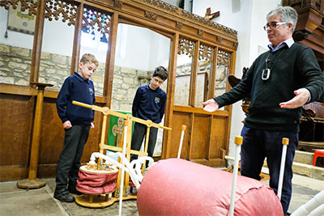
Wells Cathedral is delighted to be able to offer an exciting programmed day for Year 5 to Year 9 pupils exploring links between music and STEM subjects when the incredible, hands-on WOOFYT Workshop comes to visit!
WOOFYT – A Wooden One-Octave Organ For Young Technologists – is the invention of professional violinist and teacher, Jeremy Sampson, and retired businessman and amateur engineer, Bill Cleghorn, and provides a novel and challenging experience combining music, science & technology.
‘Although music can seem like a world apart from science, technology and engineering, there are lots of connections to be explored. The WOOFYT makes these connections visible and audible, linking music in a simple and direct way with the physics of fluids and the technology of pumps and valves.’ (Participating teacher)
Playing the instrument was very fun and fascinating! (Y6 pupil)

The WOOFYT schools’ workshop:
- Explores how pumps and valves work to create and control air flow and pressure;
- Offers a hands-on experience – work as a group to play tunes;
- Develops teamwork;
- Is inclusive of pupils with special needs.
The programmed day includes:
- A WOOFYT workshop
- A tour of Wells Cathedral
- A singing workshop with a member of the Cathedral’s specialist music department
- Lunch space and secure storage for bags and coats
Timings: The day will begin promptly at 10am with activities finishing at 2pm.
Cost: £5.50 per pupil (including VAT) with accompanying adults free of charge.
Booking: Spaces are limited and will be offered on a first come first served basis. Please contact education@wellscathedral.org.uk or phone 01749 673809 if you would like to book.
